# Screenshots of the web page.

The initial page.

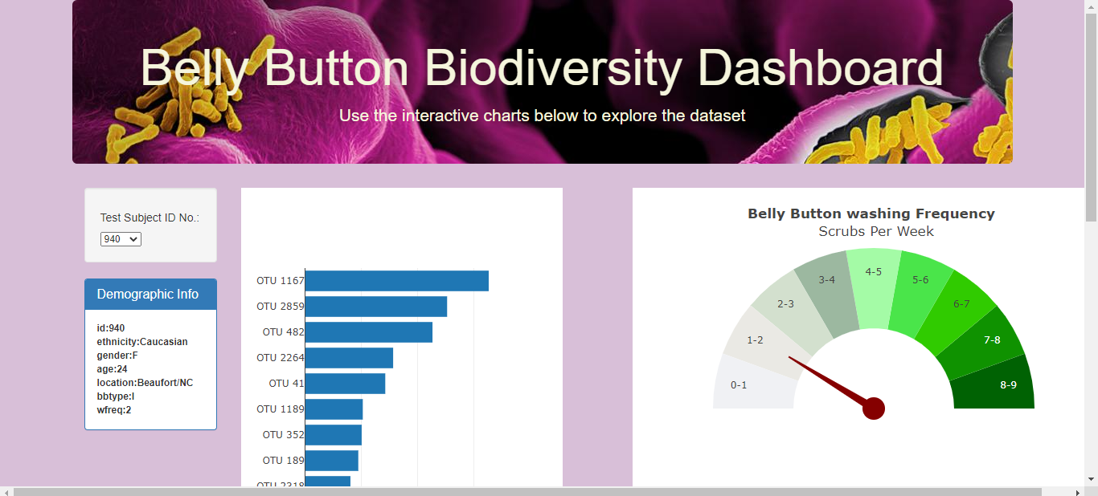

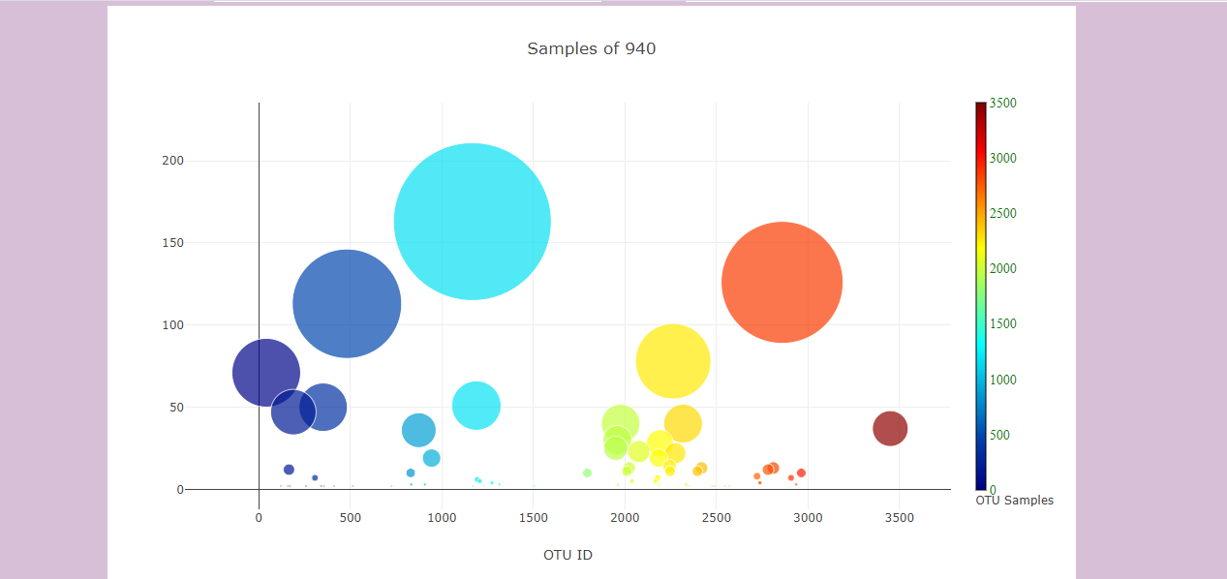

On changing the id the Charts get updated and on hovering it shows the text in the color of the sample’s color.

